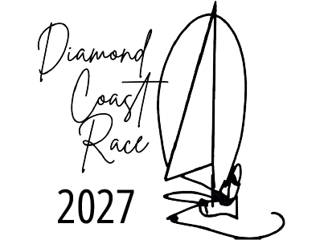



SAFETY DECLARATION FORM
This declaration is to be completed, signed by the skipper and/or appointed crew member and submitted to the Race Secretary by 17h00 on Friday 6th March 2027.
Name of yacht:
Sail No: |  |  |  | Club:
Name of Skipper:
Name of appointed crew member:

We declare that the above yacht complies with all the necessary safety requirements as set out in the schedule 1 of the NOTICE OF RACE and we undertake to be available for inspection in terms of the notice of race.

List any matters to be brought to the attention of the race committee here:

SIGNED: _____________________________ DATE: ______________________
Skipper
SIGNED: ____________________________ DATE: ______________________
Safety inspector

